**IOT BASED SMART FARMING -ASSIGNMENT 2**

**SUBMITTED BY NIKITHA K (113219031100)**

**BACHELOR OF ENGINEERING IN COMPUTER SCIENCE AND ENGINEERING**

Build a python code, assume you get temperature and humidity values (generated with random function to a variable) and write a condition to continuously detect alarm in case of high temperature.

**CODE:**

**import random**

**temperature= random.randint(0,200)**

**humidity= random.randint(0,100)**

**print("The recorded temperature in fahrenheit =",temperature)**

**print("The recorded humidity in percentage =",humidity)**

**if(temperature >135 or humidity>50):**

**print("Fire alert-Alarm on")**

**else:**

**print("Alarm Off")**

**OUTPUT:**

**CASE 1: ALARM ON:**

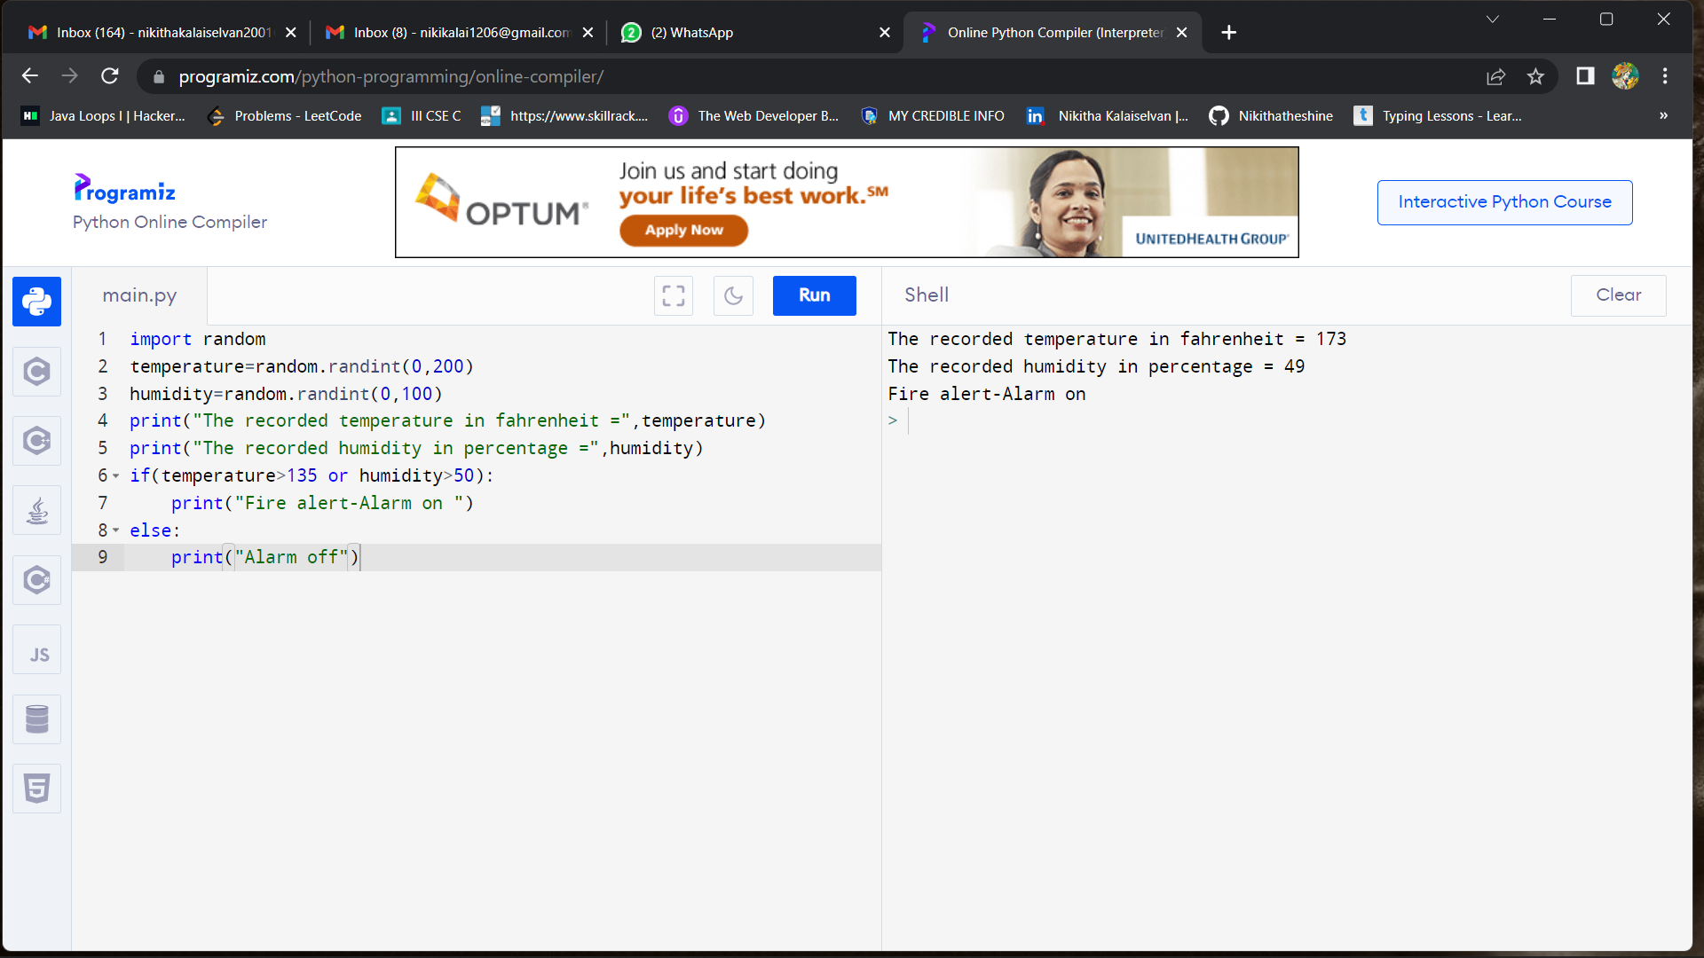

**CASE 2: ALARM OFF**

